**WEB DESIGN**

**PROJECT REPORT**

|  |  |
| --- | --- |
|  | **PROJECT TEAM** |
| **Student No.** | **Student Names** |
| **x18402726** | **Sophie Moore** |
| **x18119859** | **Dylan Brennan** |
|  |  |

# Dublin Books

<http://dublinbookstore.gear.host>

Contents

Dublin Books 1

Section 1: Design 3

1. PROJECT PROPOSAL 3

1.1. Project Overview 3

1.2. Research / Investigation 3

Conclusions of research 5

Requirements & Technical Approach 6

Technical approach 7

Section 2: Development 8

Splitting Workload 8

Validation 9

Test Cases 15

Third party sources 16

Accessibility Standards 17

Section 3: References 19

References 19

22

Index (Main Page) 23

# Section 1: Design

## 1. PROJECT PROPOSAL

### 1.1. Project Overview

The website is for a bookstore located in the heart of Dublin City. Customers should be able to navigate the website to see new releases and promotions. Customers should be able to order books through the website for home delivery.

## 1.2. Research / Investigation

Chapters

**URL:** https://www.chapters.ie

What is great about this website is the layout. It is a very neat and tidy website with plenty of images to show you what they have to offer (second hand books, new books)

Their opening and closing hours are easy to find and also easy to read making this pleasant for the viewer. The colour scheme is simple and neutral, it wouldn’t be likely to offend any visitors but also doesn’t offer much in the way of stylistic impression. The website does not have any sort of online ordering system available.

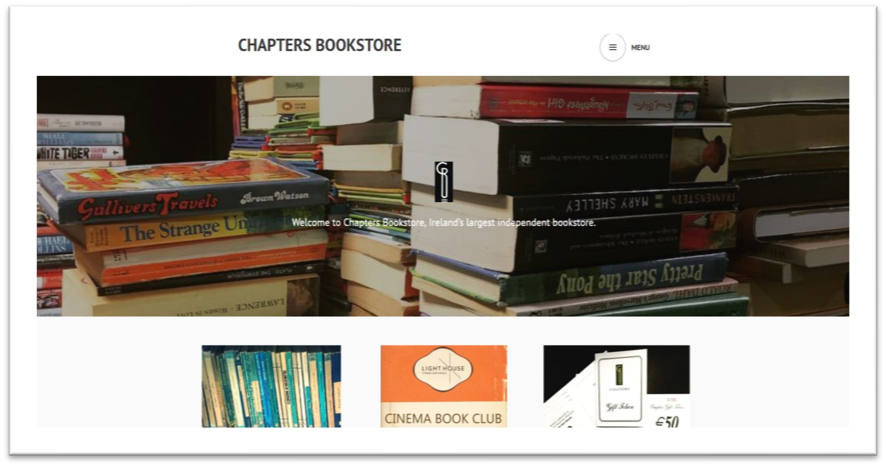

Fig 1. Homepage for Chapters Bookstore htp://chapters.ie/

**Hodges Figgis**

**URL:** https://www.waterstones.com/bookshops/hodges-figgis

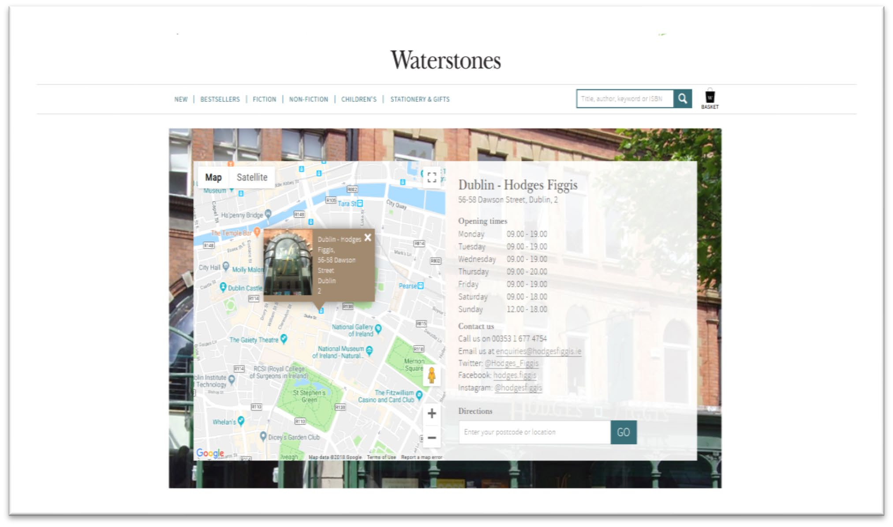

*Fig 2. Homepage for Hodges Figgis htps://www.waterstones.com/bookshops/hodges-fggis*

What is liked about this website is the overall colour scheme, the website uses soft colours that don’t distract you from the information that is given.

However, it is not ideal for the website to be taken up by an insert of google maps before any user could see the actual content.

The navigation menu is easy to use and functional as it gives us many categories of books as well as stationary needs. A small paragraph detailing the history of the bookstore can be seen on the main menu and gives the viewer some information about the store. The website offers the ability to order a book online and collect it in person, there is no option available for order online & home delivery.

**The Gutter**

**URL:** http://gutterbookshop.com/

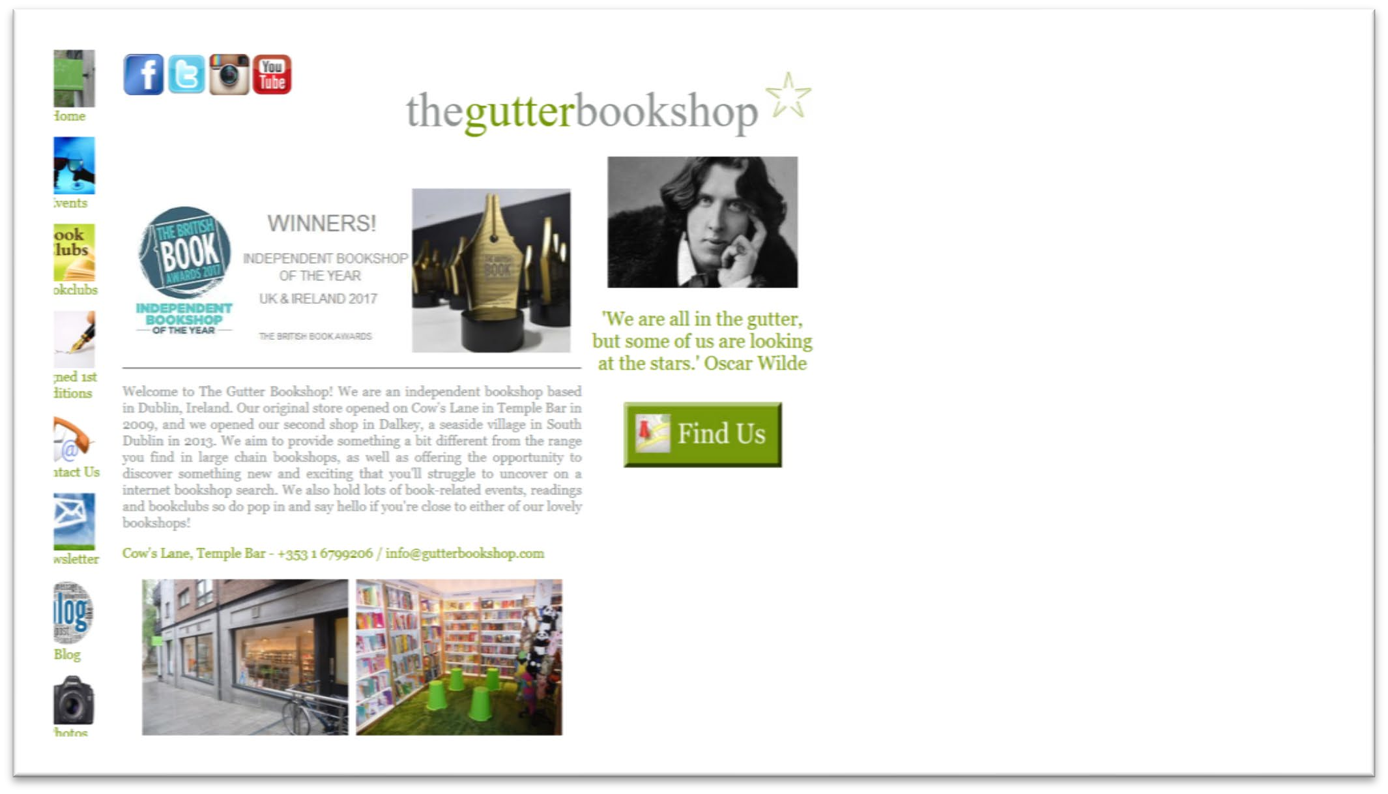

*Fig 3. Homepage for The Gutter Bookshop https://gutterbookshop.com/*

The entire functional part of this website is aligned to the left side of the screen, which leaves 60% of screen space wasted. The site does not scale to accommodate mobile/tablet devices. The colours and styling used and minimal and don’t engage the user with the nature of the sites content. The images used are small and not of high quality. The load time of the website has been slow on occasion, affecting user experiencing negatively. The website does not offer any methods through which users can order or reserve books online.

## Conclusions of research

Many competitors within the market either offer inspiration or functionality but fall short of finding the balance between these key design principles. The aim of design phase is to deliver a website which finds this balance to drive book sales and grow the business.

Based on competitor research 3 key elements were highlighted which needed to be implemented into the design phase. The first of these was to balance the functionality of the website layout with inspirational elements. The second was having decided the bookstore and therefore this website should have a specialized range. Having a smaller and more focused range allows the developers to be experts in particular genres and corner their market. The final key element was to ensure that the website is easy and intuitive to navigate.

The online competitor research highlighted a gap in the market for a website which was both desktop & mobile friendly. Having a website which is mobile friendly as a design principle is absolutely essential as it outlined by Eric Enge in his when he states that “over *half of web users now access the internet through their phone or tablet device”* (Mobile vs Desktop Usage in 2018: Mobile widens the gap )– Eric Enge 2017.

In store visits to competitor bookstores in Dublin allowed a key insight into different stores offerings and unique selling points. Chapters on Parnell Street has a large collection of second-hand books on offer, due to space limitations it isn’t possible to make their range size. From this observation it was decided to specialise by having genres of focus (Murder-mystery). This special category of genre will be highlighted on the website landing page in order to help differentiate the bookstore from its competitors.

One of the competitive edges this website should provide is a platform through which online orders can be processed conveniently and quickly by the users.

## Requirements & Technical Approach

**Requirements**

The website has several key requirements to fulfil to be considered successful;

* Enable customers to place orders online
* Enable customers to view our range of books on offer
* Promote repeat business through highlighted the membership programme
* Allow visitors to learn more about the store
* Allow visitors to get in touch with the store
* Engage visitors with the idea of reading & enjoying stories
* Be simple and intuitive to navigate
* Scale to the user’s screen size
* Cross-browser compatibility

## 

## Technical approach

The project will be built using HTML, CSS and JavaScript.

The technical approach which has been planned will incorporate a number of best practice web development techniques in order to deliver a concise, inspiring and valuable website.

The first aspect to be undertaken when beginning development is to build a site-map of the project. Being able to visualise the overall website content and how it is linked is essential to understanding if the planned site will meet the requirements set out by the research already undertaken.

The second aspect is to build wireframes of each page. The wireframes should possible keep a similar overall navigation layout in order for the user to navigate the website intuitively. Both desktop and mobile wireframes need to be created for this project.

Sourcing media for the website is the third element to be undertaken, the website will need images, logo’s and potentially a video. To keep costs low, creative commons content will be utilised where possible.

After these stages have been undertaken it is essential to meet as a team and discuss the progress of the project, at least once a week. Breaking down the project into smaller sections to ensure both members of the team are engaged with and contributing towards the completion of the project. If any areas of difficulty arise they can be dealt with collectively in order to continue to progress of the project.

# Section 2: Development

## Splitting Workload

Of course with any team project, it is important to make sure that both students carry out their requirements and have the requirements equally assigned.

With this project, it was essential for the team to understand what their tasks were and have a well thought out plan for each segment. This can be done by creating a to-do list with the name of the person next to the task for each web page. By having a to-do list that both students can access, it is easier for the team to understand the work that needs to be done.

Meeting up after college time is also essential for any group in a project. It gives the students more time to finalise the project ideas and also gives them a head start. Only working on a project during college times can have consequences as there is never enough time in the working day to finish tasks.

Communication is the most important element for these projects so that students can say their points and ask questions and discuss the requirements. It helps the students to be friendly and cooperative with the occasional disagreement.

This group was able to split their workload by following these steps. By communicating, they were able to separate the most important requirements from the less important requirements. As well as this, they were able to determine who was doing what task and how well it needs to be done.

This group also met up outside of college to work on this project. They were able to get a lot of work done by going to the library and working on the computers there. This is a non-distracting environment that helped them be more focused.

This group created a to do list:

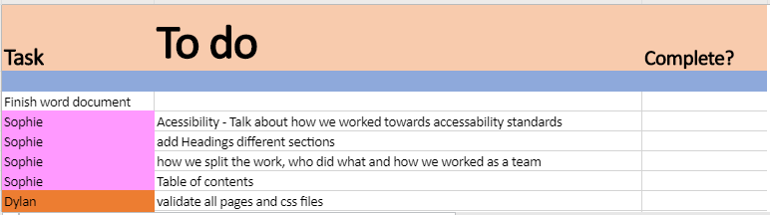

This was to ensure that no one overwrote anybody’s work and knew exactly what task they were given.

## Validation

**HTML**

The HTML code for this project was validated using the W3C mark-up validation service hosted at <https://validator.w3.org>

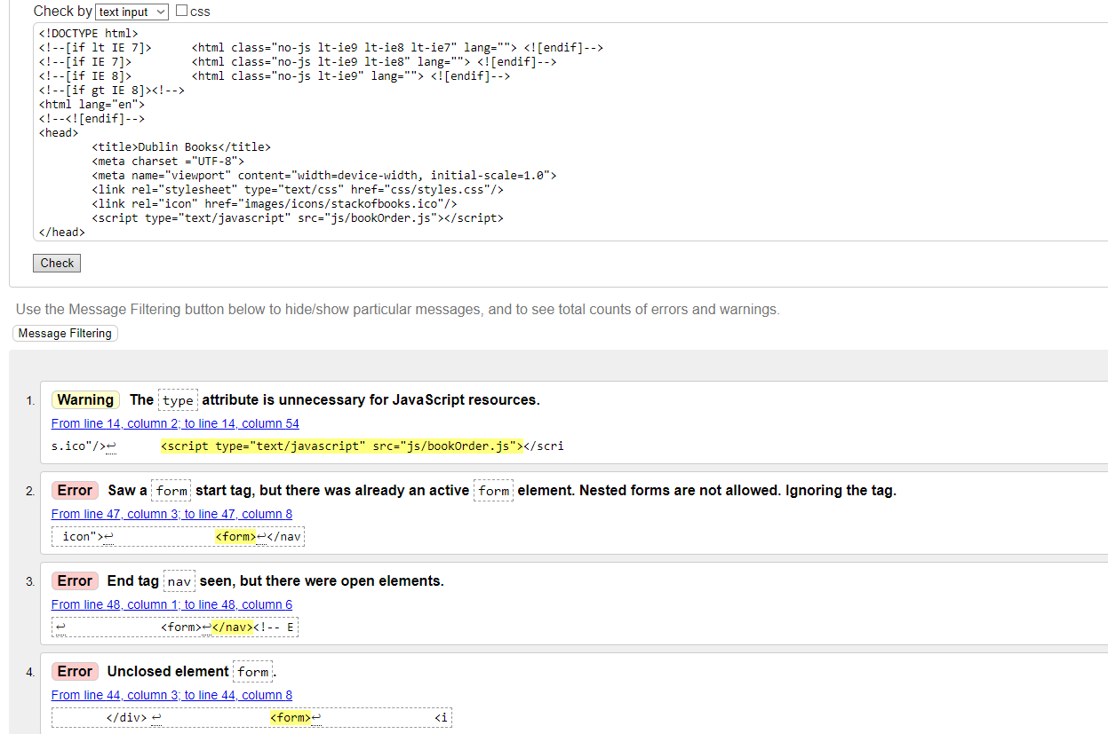

Above is a common example of some of the errors highlighted during project construction, most of these errors were small syntax errors and we’re quickly resolved to be fully compliant with HTML5 standards.

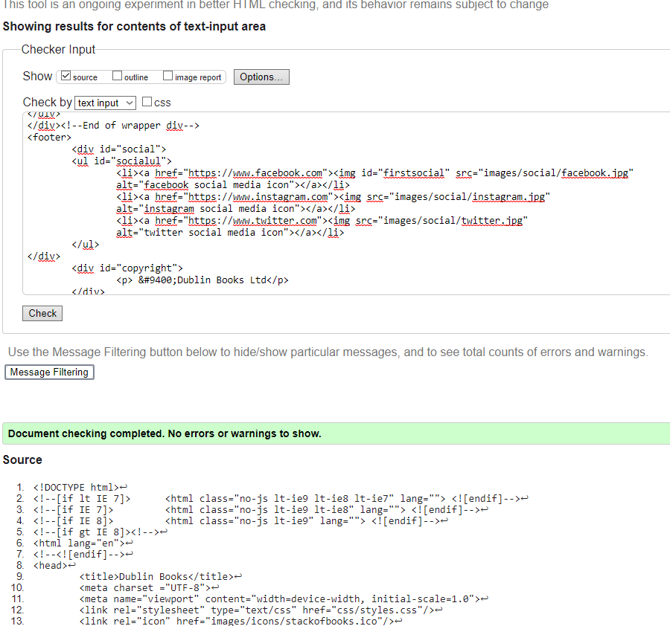

Example of fully validated and compliant HTML5 page after errors highlighted and resolved.

More examples of HTML and CSS documents before and after validation:

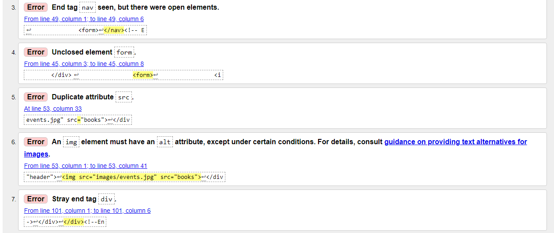

HTML Validation before correcting errors

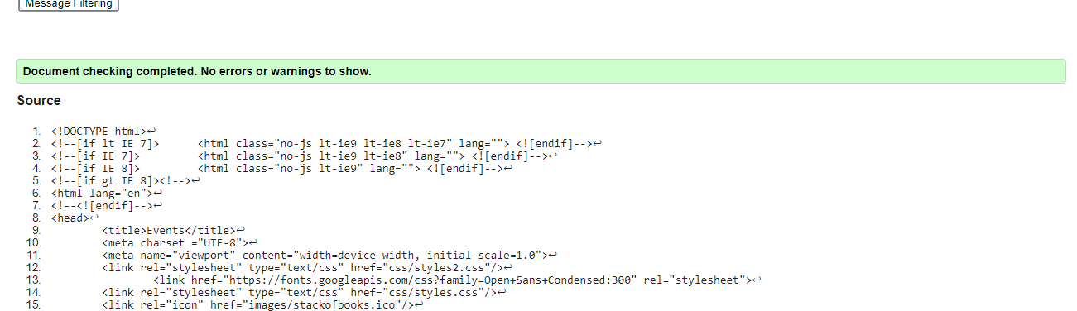

HTML Validation after correcting errors.

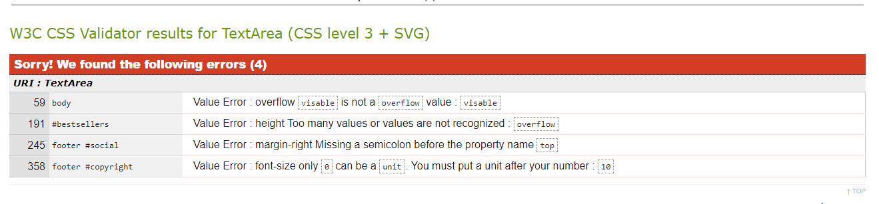CSS Validation before correcting errors.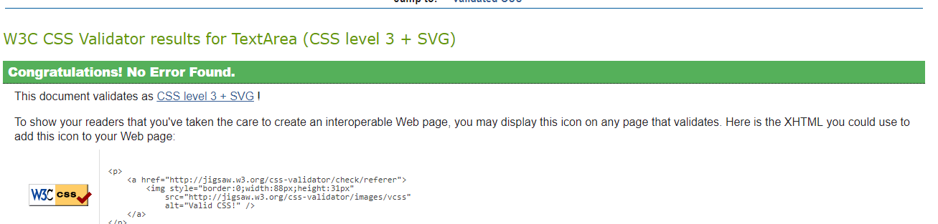

CSS Validation after correcting errors.

**CSS**

The CSS code for this project was validated using the W3C CSS validation service hosted at h <https://jigsaw.w3.org/css-validator/>

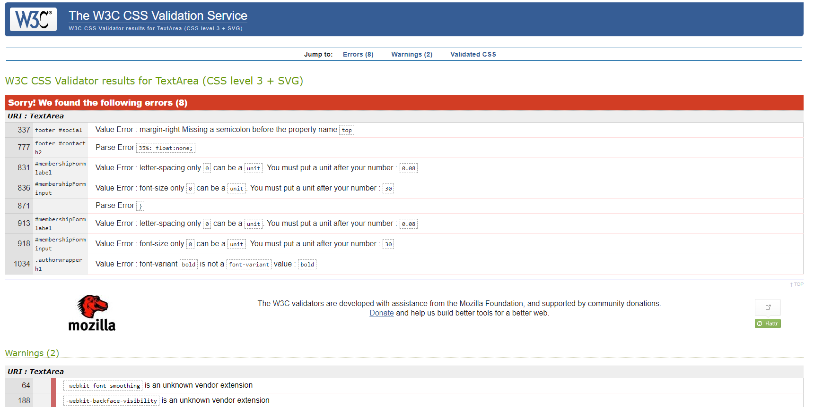

Above is an example of errors found within the CSS files, these we’re again mostly syntax based and quickly resolved in order for the website to be fully compliant with CSS3 standards.

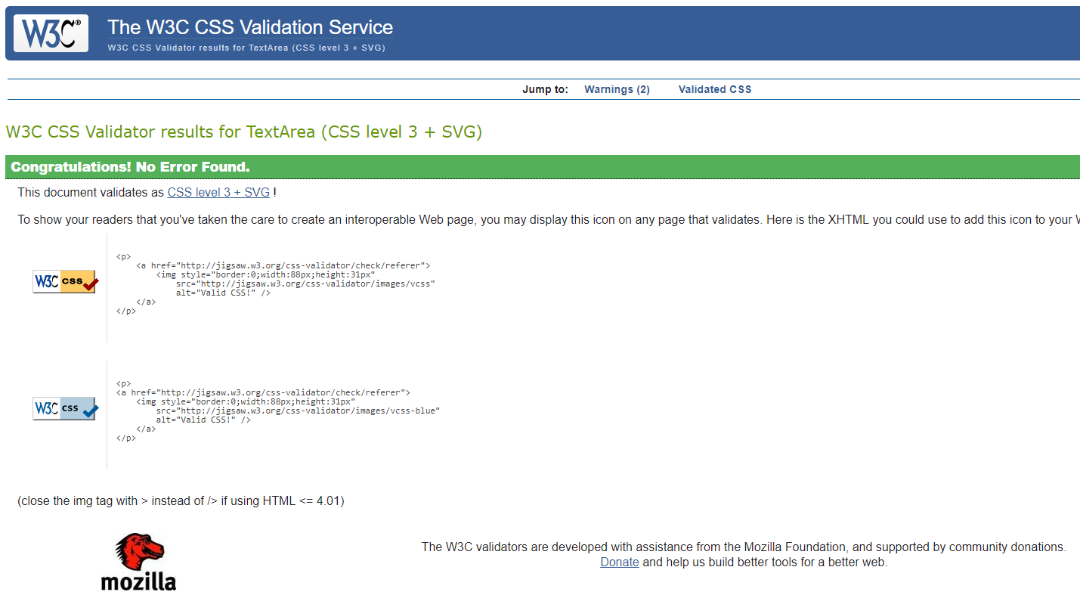

## Test Cases

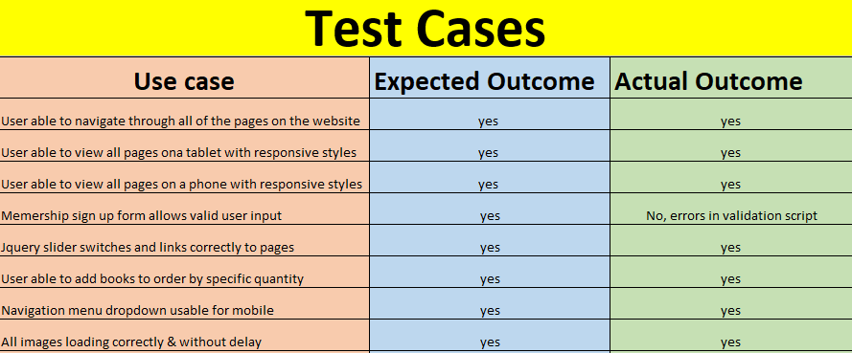

This image is the template utilised for writing and recording testing during website development. Testing of the website involved writing test cases based on the initial website requirements and deliverable features and validating them against expected and actual outcomes. A key issue highlighted during one of the later testing phases was an issue with the members signup form. Based on this particular test measures were taken to rectify the underlying issues with the JavaScript involved and ensure the final website was meeting and exceeding initial specified requirements.

## Third party sources

The website contains a variety of third-party media. These were obtained under various creative commons licenses. No proprietary media was used or purchased for this project.

**I**mages

All images used were sourced through websites offering only images through creative commons license.

The sites used to source images and their licenses are listed below:

<https://pixabay.com/en/service/terms/#usage>

<https://www.pexels.com/photo-license/>

<https://unsplash.com/license>

<https://stocksnap.io/license>

Scripts

The only third-party JavaScript utilised within the website was the image slider.

This script was sourced at <https://github.com/viljamis/ResponsiveSlides.js>

The author, Viljami Salminen made it available for use under the MIT license

More detail here <https://github.com/viljamis/ResponsiveSlides.js#license>

**Fonts**

There was on third-party for used in the website for the author.html page headings.

It is called ringbearer.ttf and was made available by it’s creator for free with restrictions in place in terms of commercial use/page views which this website will be fully compliant with.

More detail available here <https://www.dafont.com/faq.php#copyright>

## Accessibility Standards

When doing this website, there were many accessibility standards to hit in order to make it the best it can be.

We followed the guidelines established by W3c in order to have the best accessibility standards for our website.

**HTML Code:**

By keeping HTML code semantic HTML ensures that the code is easy to understand for visitors of the website and screen readers.

we used an element in order to create it (<button>) No divs were used to create the button.

By using semantic HTML, this will provide viewers with a good navigation and interaction with the website.

**Font Sizes:**

When developing a website, it is important to have a clear font size that’s easy to read and is in style with the website itself.

If you don’t have a clear font size in your website, it’ll make it hard for the viewer to read and in turn have then not want to continue reading your website.

For this website, there was a third party font used for one of the pages (author.html) it was called ringbearer.ttf. This made the website easy to read and added nice styles to make it unique.

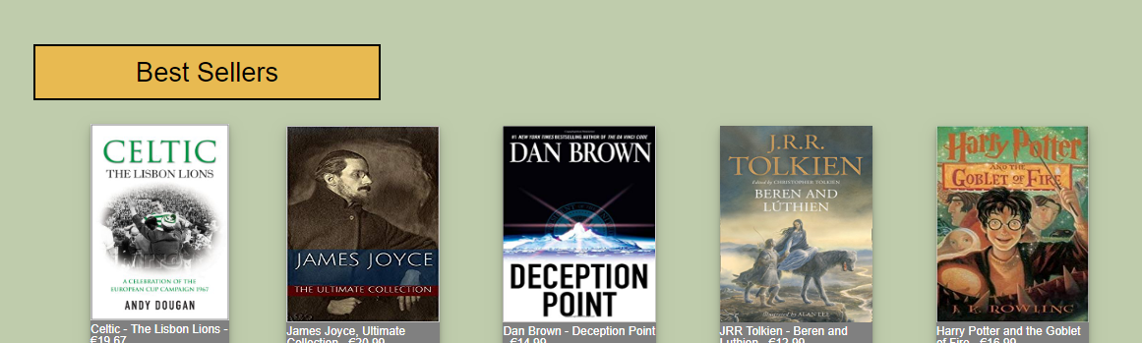

Above is an example of a font used, as you can see it is easy to read and not hard on the eyes.

**Images:**

For this website, images were a must as they give the website character and helps the visual aid of the viewer. Images that state what the page is about or is somewhat related to the content is definitely a must have as they give an easy description of the page before the viewer reads the content.

As this is a website about a bookstore, there were many images that had to implemented into the page such as new releases and bestsellers. By using websites such as pixabay and pexels, it was easy to acquire these images and use them to make the website neat and colourful.

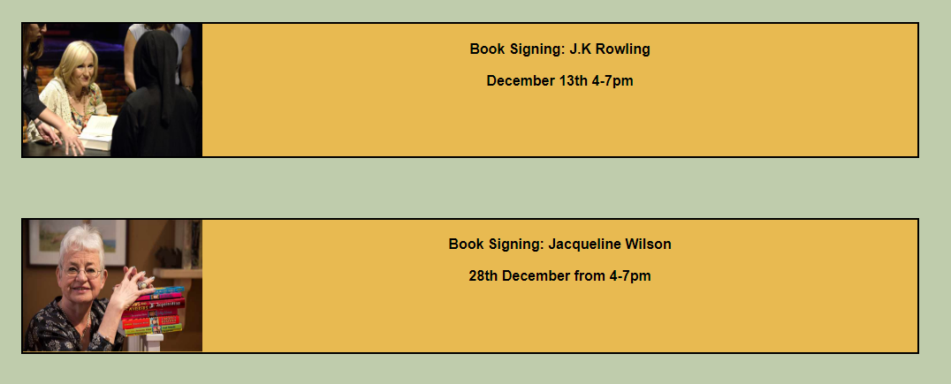

Above are examples of images used in the events page, they are clear and at a decent size so it is visually appealing.

**Easy to use:**

By having a website that’s easy to use, it will attract many customers and viewers and that is one of the main aims of creating a website.

Having an easy to use navigation bar that brings you to each page in one click is a must in modern websites as society can tend to be too impatient and expect fast paced working websites.

For Dublin Bookshop, having easy to access pages was a must as viewers needed to see the books quickly and without much fuss. With a fully functional navigation bar that shows the names of pages was the one way to create an easy to use website.



Above is the navigation bar used for our pages, it is spacious, and the viewer can find each page with ease

**Responsive pages:**

In order for viewers that have many devices to enjoy our website, we have made all our pages responsive to both mobile and tablet.

Catering to every type of device is important as it expands the viewer count of the website as it can be accessed through devices other than a desktop computer or laptop.

There is a responsive footer and header that will shorten in width when a mobile user goes to access our website.

The header is easy to navigate and is just like the desktop navigation bar with the names of the various pages.

Here are examples of our responsive web pages.

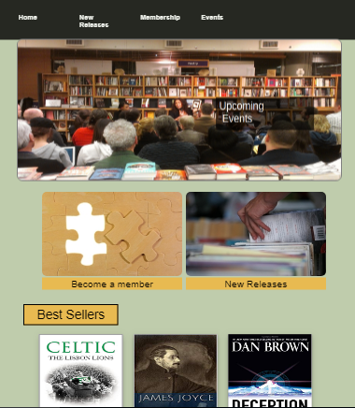

Above you can see the home page that is responsive with iPad and iPad Pro.

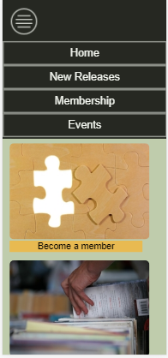

Above you can see the home page that is also responsive to all mobiles. This is currently being shown on an iPhone X. The navigation bar is responsive and blends in nicely with the rest of the homepage.

**Conclusion**

The project went really well, there was a clear vision as to what was needed to be done and once the work started, there was nice flow.

There was initially a plan of having 7 HTML pages in total, the page which was ultimately left out was the mystery novels page. It was felt that this page wasn’t necessarily adding any new complexity when compared with what was already in development. Also the competitor research conducted highlighted the absence of comparable retailers offering online shopping, which became our unique point of advantage over the competition, instead of specialising in a specific genre.

Although some of the coding elements were extremely tricky and frustrating, the project came out the way it was intended to and now we are happy with the results.

If there had been more time to finish this project, I would’ve spent a lot more time looking at the intricate details of the website that were confusing and understood them then and there to help in the future. I would’ve also spent more time focusing on making my pages the best they could be.

# Section 3: References

## References

Author: Eric Enge

Article title: Mobile to Desktop stage in 2018: Mobile wins the gap Website title: Stone Temple URL: htps://wiwiwi.stonetempcle.com/mobicle-vts-veesktop-vusage

**List of Figures:**

Figure 1: Homepage for Chapters Bookstore http://chapters.ie/

Figure 2: Homepage for Hodges Figgis https://www.waterstones.com/bookshops/hodges-figgis

Figure 3: Homepage for The Gutter http://gutterbookshop.com/

**Site Map and Wireframes**

### 

### Index (Main Page)

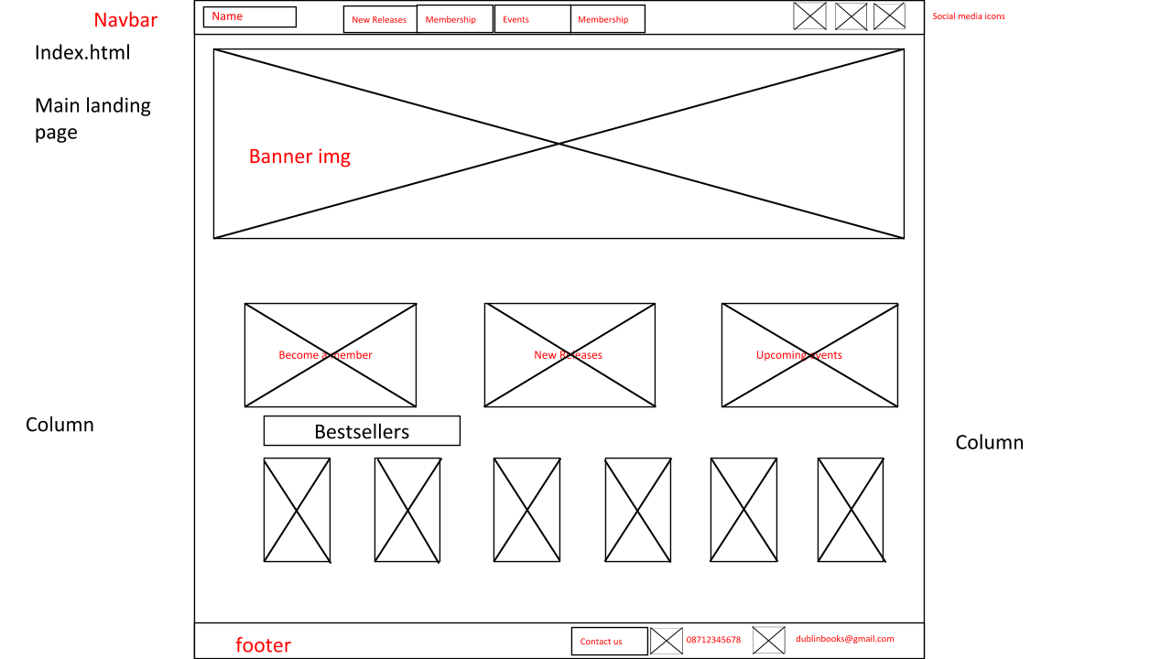

**Mystery Novels page**

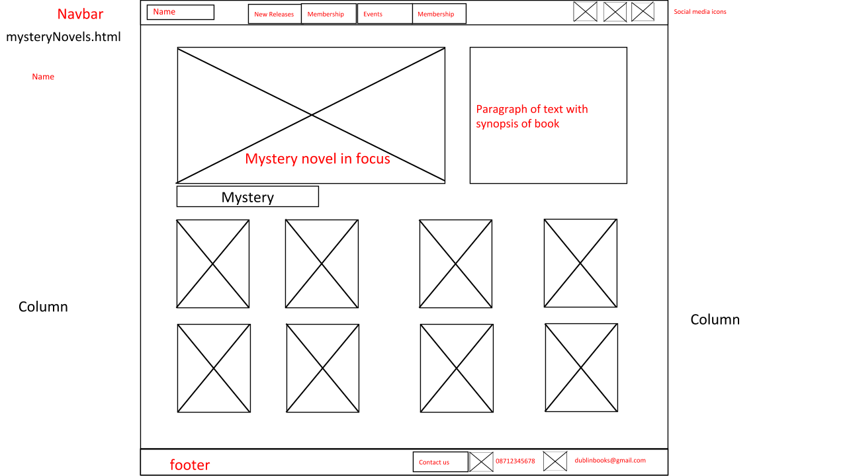

**Author in focus page**

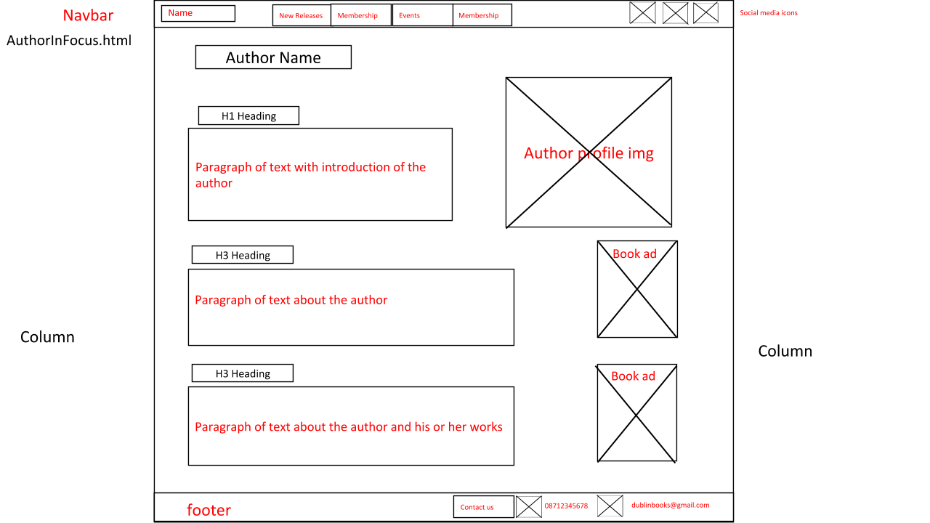

**Book page**

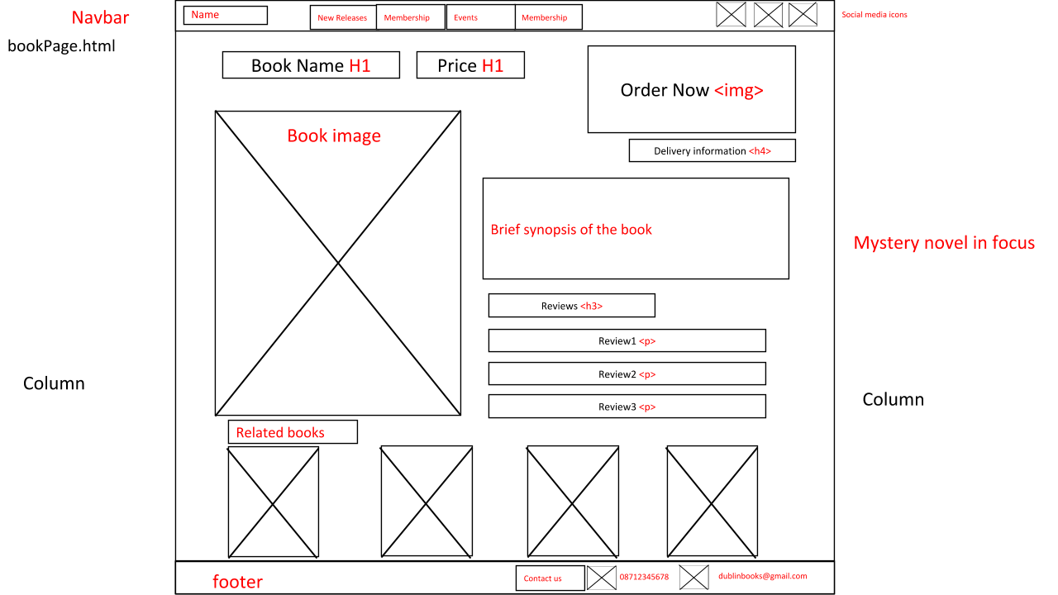

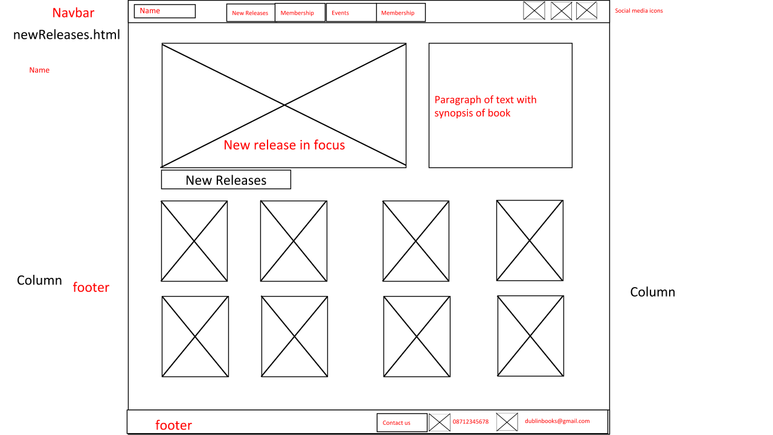

**Events page**

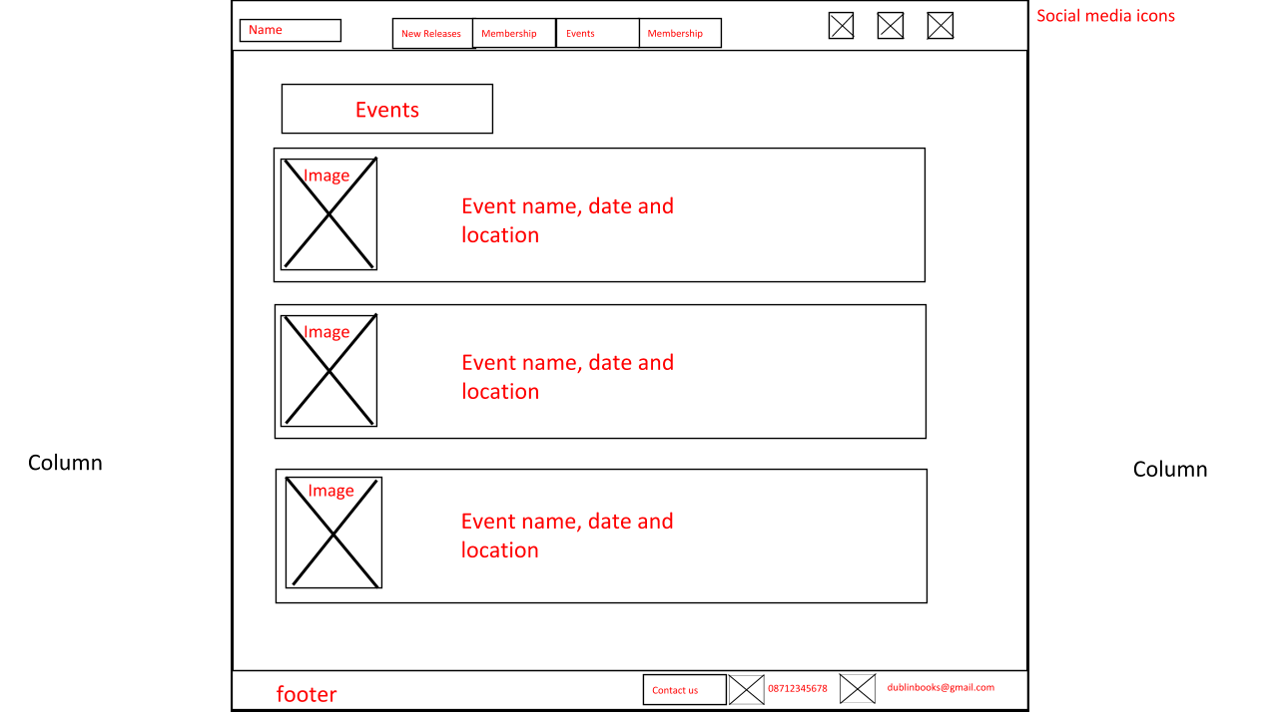

**Members Sign-up page**

